Easy & Simple
By: Hassan Iqbal, Abdul Wahab Khan, Tania Sardar.
Roll No: 20, 17, 33.
Department: Software Engineering.
Program: Software Engineering Technology (SET).
Submitted To: Engineering Zeeshan Ahmed.
Weather Report System
Topic :

Final Project
Universty of Azad Jammu and Kashmir
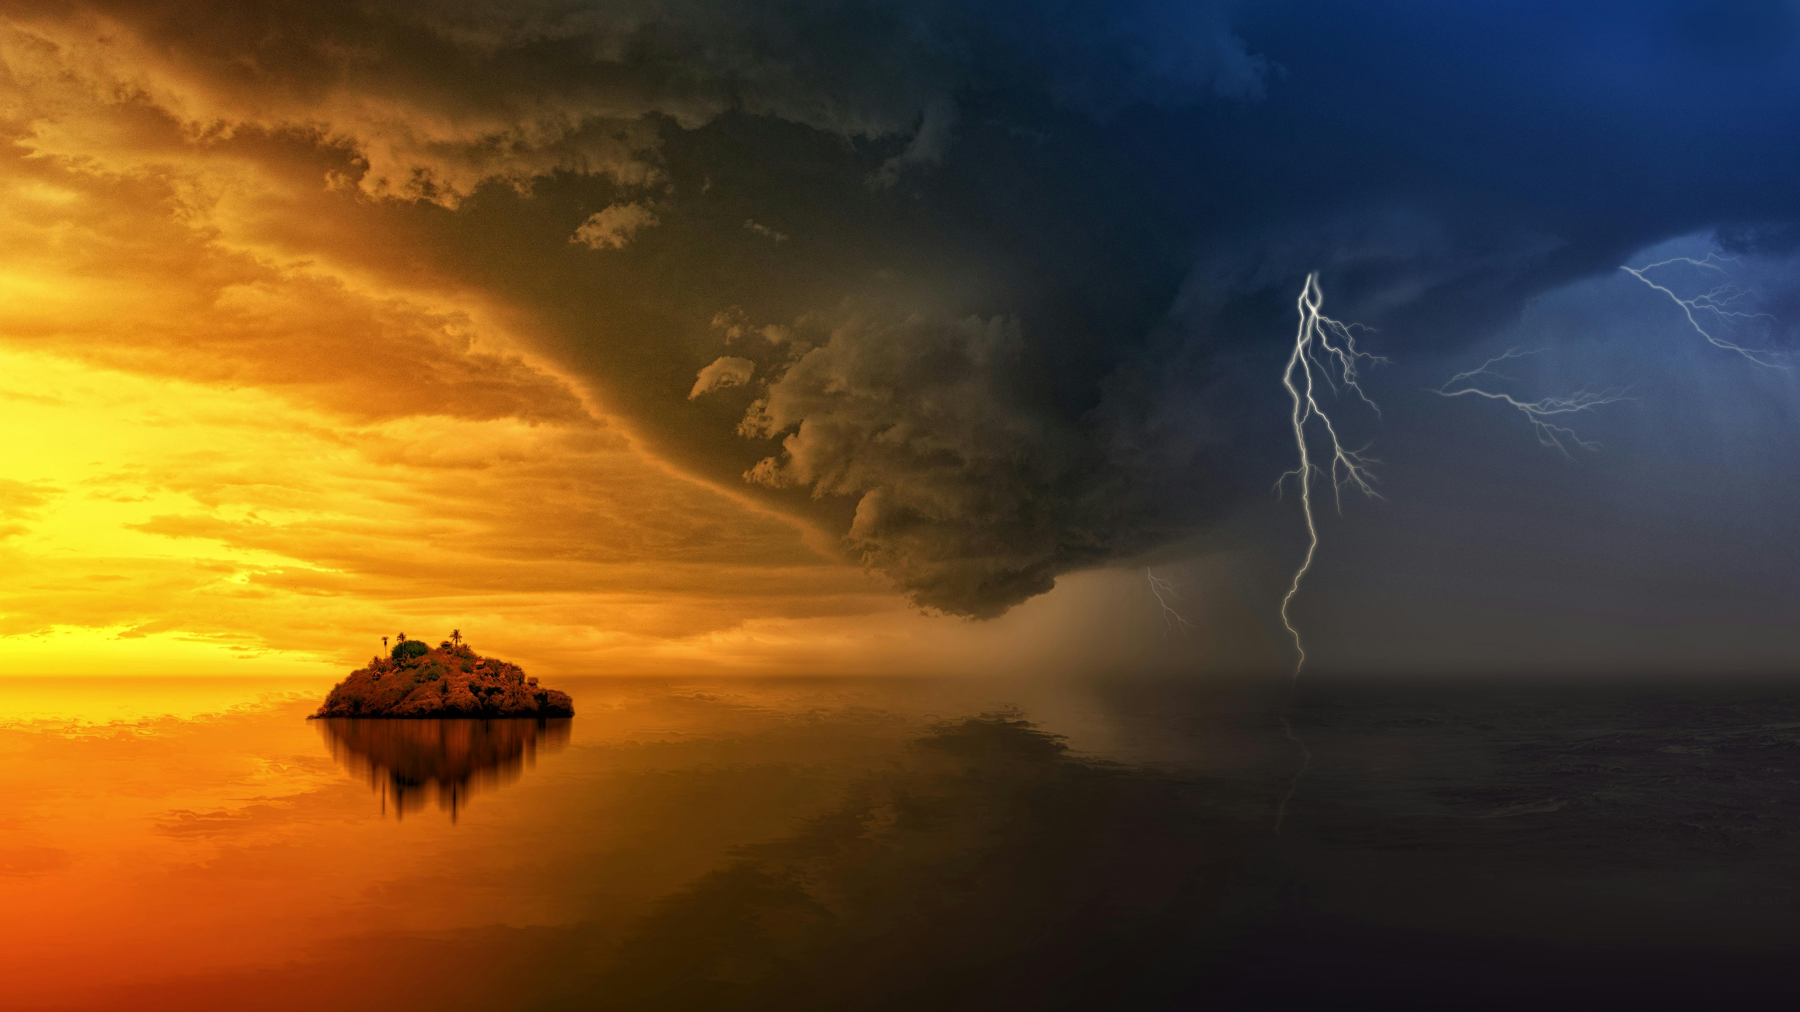

Weather Report System:
A Weather Report System is a system that collects, analyzes, and presents information about atmospheric conditions of a particular place and time. It helps people understand current weather conditions and predict future weather to plan daily activities, agriculture, aviation, disaster management, and many other fields.

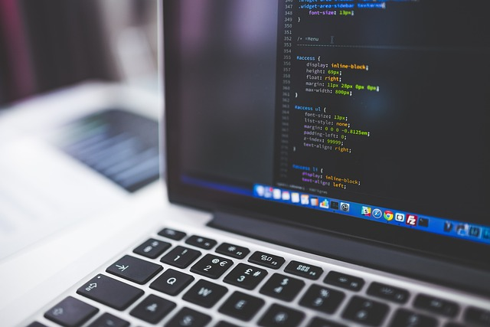

1. Meaning of Weather:
Weather refers to the day-to-day condition of the atmosphere at a specific place. It includes factors such as:
- Temperature.
- Humidity.
- Rainfall.
- Wind speed and direction.
- Air pressure.
- Cloud cover.

2. Purpose of Weather Report System:
The main purposes of a weather report system are:
- To inform people about current weather conditions.
- To forecast future weather.
- To warn people about extreme weather events (storms, floods, heatwaves).
To support sectors like agriculture, transportation, tourism, and disaster management.

Weather Report System
Final Project


Weather Report System
Final Project

d) Weather Forecasting:
Forecasting is the process of predicting future weather conditions. Types include:
- Short-term forecast (few hours to 2 days)
- Medium-term forecast (3–7 days)
- Long-term forecast (weeks or seasons)
Forecasts are prepared using:
- Numerical weather prediction models
- Satellite images and radar data

b) Data Transmission:
Collected data is sent to weather centers through:
- Internet networks.
- Satellite communication.
- Radio signals.
This ensures real-time and accurate data delivery.

3. Components of Weather Report System:

a) Data Collection:
Weather data is collected using different instruments and sources such as:
- Thermometers: Measure temperature.
- Barometers: Measure air pressure.
- Hygrometers: Measure humidity.
- Anemometers: Measure wind speed.
- Rain gauges: Measure rainfall.
- Weather stations: Automatic or manual stations placed at different locations.
- Satellites: Observe clouds, storms, and large weather patterns.
- Radar systems: Detect rainfall and storm movement.

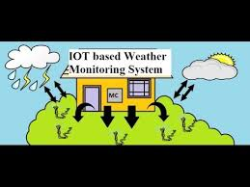

5. Importance of Weather Report System:

a) Daily Life:
Helps people decide:
- What to wear.
- When to travel.
- Outdoor activity planning.

b) Agriculture:
- Guides farmers about irrigation.
- Helps protect crops from frost, floods, or drought.

c) Transportation:
- Ensures safety in aviation and marine travel.
- Helps plan road journeys.

d) Disaster Management:
- Early warnings for cyclones, floods, and heatwaves.
- Saves lives and reduces property damage.

e) Tourism:
- Helps tourists plan trips according to weather conditions.

6. Modern Weather Report Systems:
Modern systems use:
- Artificial Intelligence (AI).
- Machine Learning.
- Supercomputers.
- Remote sensing technology.
These technologies improve accuracy and speed of weather forecasts.

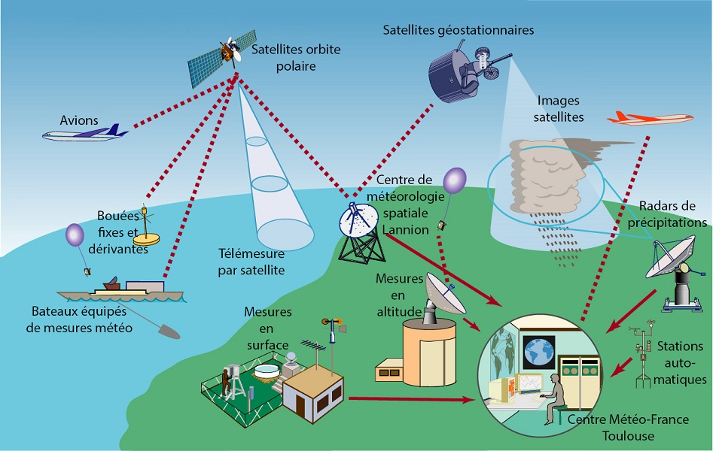

7. Limitations of Weather Report System:
- Weather is complex and changes rapidly.
- Long-term forecasts may not always be accurate.
- Dependence on technology and data quality.

8. Conclusion:
The Weather Report System plays a vital role in modern life. By collecting and analyzing atmospheric data, it provides valuable information that helps individuals, governments, and organizations make informed decisions. With advances in technology, weather forecasting is becoming more accurate, reliable, and accessible.

Related Programs:
1. Current Weather Display.
2. Weather Forecast.
3. Temperature Conversion (Celsius to Fahrenheit etc.)
4. Weather Advisory System.
5. City-wise Weather Report.
6. User Input for City Weather.
7. Weather Statistics.

Thank You

d) Weather Forecasting:
Forecasting is the process of predicting future weather conditions. Types include:
- Short-term forecast (few hours to 2 days)
- Medium-term forecast (3–7 days)
- Long-term forecast (weeks or seasons)
Forecasts are prepared using:
- Numerical weather prediction models
- Satellite images and radar data

b) Data Transmission:
Collected data is sent to weather centers through:
- Internet networks.
- Satellite communication.
- Radio signals.
This ensures real-time and accurate data delivery.

3. Components of Weather Report System:

a) Data Collection:
Weather data is collected using different instruments and sources such as:
- Thermometers: Measure temperature.
- Barometers: Measure air pressure.
- Hygrometers: Measure humidity.
- Anemometers: Measure wind speed.
- Rain gauges: Measure rainfall.
- Weather stations: Automatic or manual stations placed at different locations.
- Satellites: Observe clouds, storms, and large weather patterns.
- Radar systems: Detect rainfall and storm movement.

